Udaya Public School, Ayodhya
Summer Holiday Homework- 2022-23
Class- IX
Subject- English
Love House: -
Think and write a short account of what life in Rameswaram in the 1940’s must have been like were people rich or poor? Hard working or lazy? Hopeful of change, or resistant to it?

Unity House: -
Do you think you will accept a job because it offers an exorbitant salary even if you do not wish to take it yp? Share your thoughts by writing a short paragraph of 200 words.

Hope House: -
Collect information about the top three hotel chains in the country from the internet, take down customs reviews rating the services and amenities provided. Then make a comparative Chart.

Zeal House: -
Imagine you are on a long journey to your remote ancestral village. You have to travel by train then by car and finally bullock cast. Use adverbs to describe your journey, in detail.
Draw a route map of the places that you crossed during your journey.

Common Questions: -
how many different kinds of birds do you come across in your life, How many you have seen Written 200 words and make beautiful chart.

Subject- Hindi
Love House: -
आपके अनुसार वस्तुओं को खरीदने का आधार वस्तु की गुणवत्ता होनी चाहिए या उसका विज्ञापन ? तर्क देकर स्पष्ट करें |

Unity House: -
आपकी दृष्टि में वेश-भूषा के प्रति लोगों की सोच में आज क्या परिवर्तन आया है ? आपकी वेश-भूषा कैसी है ? लिखिए|

Hope House: -
आपने भी किसी स्थान की यात्रा अवश्य की होगी ? यात्रा के दौरान हुए अनुभवों को लिखिए |

Zeal House: -
कृषि प्रधान समाज में पशुओं का क्या महत्व होता है ? आज के समय में पशुओं की क्या दशा है ? लिखिए |

Common Questions: -
बचपन से अब तक आपने बहुत सी कहानिया सुनी एवं पढ़ी होंगी, कौन सी कहानी से आपको सबसे अधिक प्रेरणा मिली वह कहानी लिखिए |

Subject- Maths
Love House: -
Plot the point (3,4), (-3,4), (-6,4) and (-6,4) in Cartesian plane.

Unity House: -
Define remainder theorem or Factor theorem, with suitable example.

Hope House: -
Write and explain with example all algebraic identity that is in your syllabus.

Zeal House: -
Represent 2.334 on number line and also write steps.

Common Questions: -
Make A project file on any mathematician with the contribution of him in Mathematics with example and photo.

Subject- Science

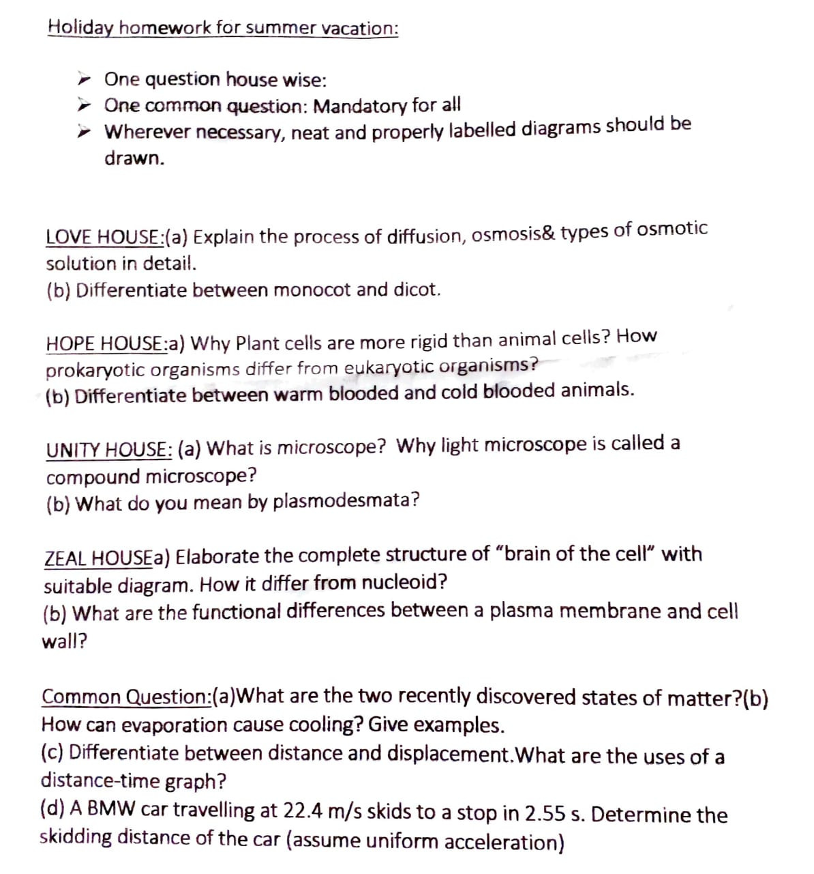

Subject- Social Science
Love House: -
Why do we need a Constitution? Name and explain three prominent personality who played important role in the making of constitution of India. (300 words) (Project file)

Unity House: -
Make a project file on “Dr. B. R. Ambedkar”. (300 words)

Hope House: -
Why do we need Democracy in a Country? Compare Democracy with other form of government. (300 words) (Project file)

Zeal House: -
Make a project file on “Women Empowerment”. (300 words)

Common Questions: -
Make a project file on “Disasten Management”. (500 words) (Separate file)

Subject- Computer
Assessment for Hope House: Create a greeting card in writer application with all the formatting features, after creating card paste it hard copy in a file.
Assessment for Love House: Create a poster in writer that should contains the main attractions in annual fete, hard copy of poster should be pasted in a file.
Assessment for Unity House House: Write thirty short cut keys in writer with description in a4 sheet papers and paste it in a file, hard copy should be pasted in a file.
Assessment for Zeal House: Create an invitation letter in writer to invite a Chief Guest in Annual Function 2022, hard copy should be pasted in a file:
Common Question:Draw the logo of four famous word processors in a4 sheet paper.

