Class- XII
Subject- English
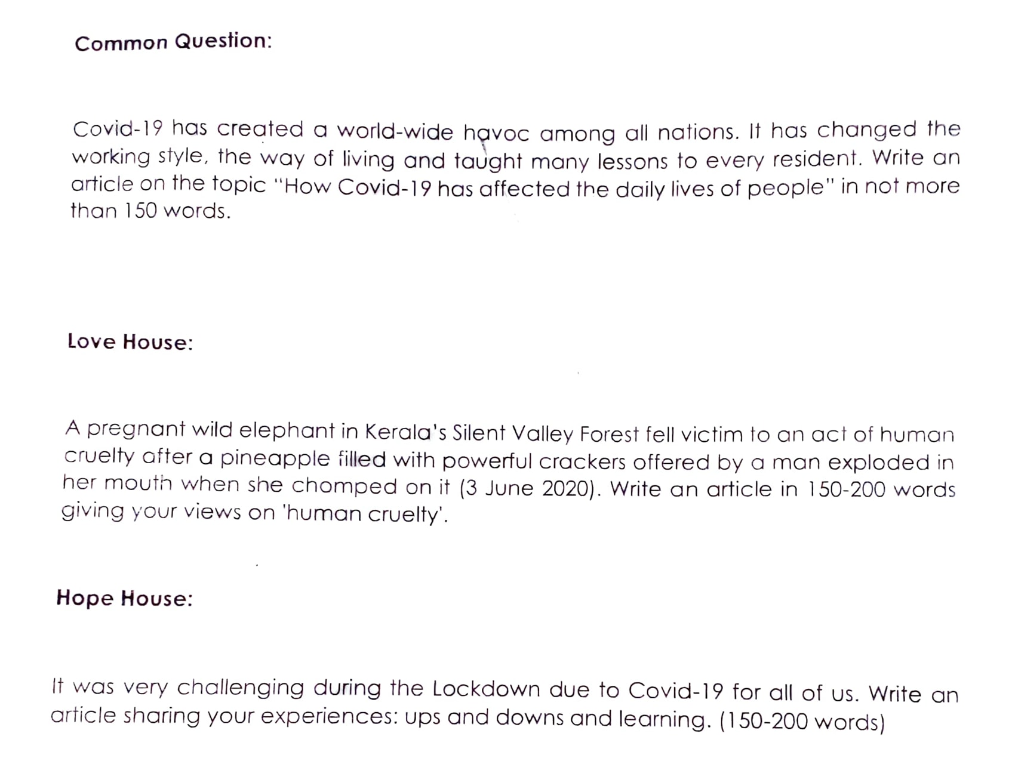
Zeal House:
Why selfishness and self-centredness cause so many problems in the world?
Unity House:
Compose your own poem on “Lockdown Survival”
Subject- Maths
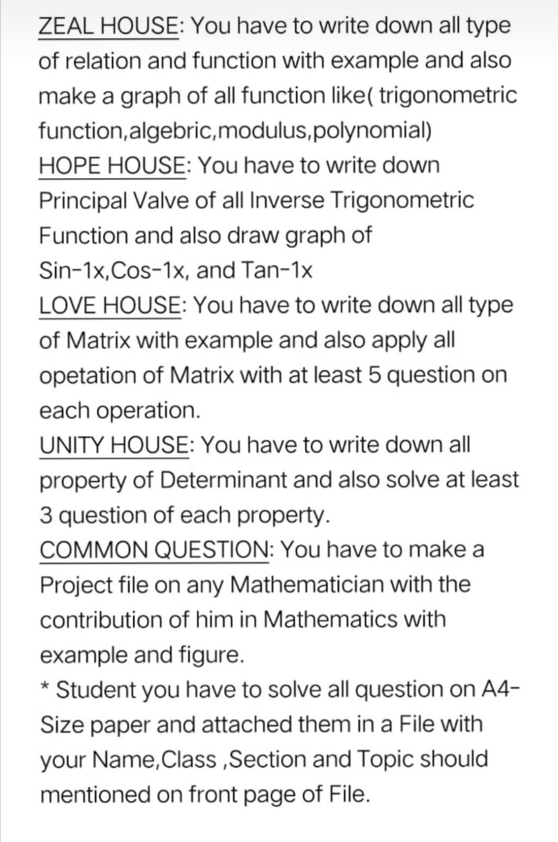
Subject- Physics
LOVE HOUSE
Question. An electric dipole is placed in a uniform electric field E with its dipole moment p ANTI parallel to the field. then find
- The work done in turning the dipole till its dipole moment points in the direction opposite to E. The orientation of the dipole for which the
- torque acting on it becomes maximum.

HOPE HOUSE
Question. Define the term electric Potential. find the electric field and potential at the axis of Ring and also draw the graph

ZEAL HOUSE
Question. Write the all properties of electric field lines and also draw the field lines of some cases

UNITY HOUSE
Question. What are the dimensions of capacitance?
Electric charge is distributed uniformly on the surface of a spherical rubber balloon. Show how the value of electric intensity and potential vary
- i. on the surface,
- ii. inside and
- iii. outside?

Common question
Plot the all graphs of chapter 1 and 2 of electric field intensity and potential

Subject- Chemistry
- Question for Hope House
MAKE A NOTS ON THE TOPIC “APPLICATIONS OF COORDINATIONCOMPOUND IN OUR DAILY LIFE”.
- Question for Love House
MAKE A NOTES ON THE TOPIC “IUPAC NOMENCLATURE OF COORDINATION COMPOUND “.
- Question for unity House
MAKE A NOTES ON THE TOPIC “ISOMERISM IN COORDINATION COMPOUND ”.
- Question for Zeal House
MAKE A NOTES ON THE TOPIC “VALANCY BOND THEORY “.
- COMMON QUESTION (COMPULSORY FOR ALL)
DO SOLVE ALL EXCERCISE QUESTIONS OF CHAPTERCOORDINATION COMPOUND
NOTE- PREPARATION OF PROPER NOTES OF ABOVE CHAPTERIS MANDATORY. IT WILL CHECK WHEN SCHOOL REOPENS.
Subject- Biology
Q1. HOPE HOUSE
State coulomb s law in electrostatic. Express SI unit s
LOVE HOUSE
Q 1 Obtain an expression for the electric field intensity at a point at a distance r from a charge q.
UNITY HOUSE
Q 1 write coulomb’s law in vector form.
ZEAL HOUSE
What is an electric dipole .Define electric dipole moment and give its SI unit
This question is compulsory for all houses

Subject- Accountancy
Common question.
Question 1.
A) A partnership is a business shared by multiple owners. It's not a legal business entity, and it doesn't have to be registered with the state. Basically, if you decide to go into business with another person without filing any state paperwork, you're automatically in a partnership.
Some types of partnerships are legal business entities registered with the state. These entities may provide limited liability protection to shield your personal assets.
A partnership, like a sole proprietorship, is legally and financially inseparable from its owners. Profits and losses may be passed through to the owners' personal income for tax purposes. Debts and liabilities pass through as well.
Partnerships are generally easier and less costly to create than corporations.All partnerships provide the advantage of pass-through taxation, which generally results in lower taxes than other business structures such as corporations.
Enlight of above para, you are required to write about Partnership and how Accounting can be done in this form of business.
B) Write Down the difference between partnership firm and sole proprietorship.Find out 5 partnership firm in Ayodhya District.
Question 2.
Hope House. Define Assets and it's types.
Love House. Define Liabilities and it's types.
Unity House.Define Expenditure and it's types.
Zeal House. Define Income/Receipts and it's types.

Subject- Economics
Common Question
- What is Government Budget, mention it’s significance?
Love House
- Why Banking function is required in an Economy?
Hope House
- What are the methods to measure money supply, explain?
Unity House
- What are the tools of RBI?
Zeal House
- Why Indian Economy was stagnant at the time of Independence?

Subject- History
Common Question
- Make a list of all Indian dynasties in sequence along with their time period and emperor.
Love House
- Make a file on Bhakti and Sufi tradition in Indian and also mention its impact on today’s life.
Hope House
- Make a file on Harappan Civilization and also shows its sites on map.
Unity House
- Make a file on Mahatama Gandhi, his straggle and movements for freedom.
Zeal House
- Make a file on Mahabharata Epic through a -------- and also mention its impact on today’s society.

Subject- Geography
Love:- Human wants are endless, but resources are limited,so conservation of resources are necessary ellaborate it.
Hope:-Sustainable development is necessary in the present situation how?
Zeal:-Disposal of wastes both liquid and Solid create a problems . How we can over come these problems?
Unity:- Ageing populations are now a days facing social, economic and psychological problems. How you can solve this problems ? Suggest a suitable measures for it.
Common:- on the map of India locate the various coal mines existed in various states.
Subject- Business Studies
Hope House
- Prepare chapter 1 (Nature and Significance of management). Written test will be conducted.
Love house
- Prepare chapter 2 (Principles of management). Written test will be conducted.
Unity House
- Prepare Chapter 3 (Business Environment). Written test will be conducted.
Zeal House
- Prepare chapter 4 (Planning). Written test will be conducted.
Common Question
- Prepare chapter 5 (Organising). Written test will be conducted.

Subject- Legal Studies
Common Question
- Make poster on (a) Right to equality. (b) Right against exploitation.
Hope House
- Take up any one concept/ value such as equality, liberty, Social Justice etc. Find out a case study where violation of these rights has been. Analyse the case and prepare a report.
Unity House
- Collect information about Justice P. N. Bhagwati and important case laws that have been given by him.
Zeal House
- Analyse the different judicial systems of the below given countries and write their features with difference and choose the best one amongst them and what features make them different from others. United states of America, Britain, Australia, India
Love House
- Make a flow chart how the Judges of Supreme Court and High Court are appointed current scenario and collect the details of current CJI if India with pictures and decided cases.

Subject- Physical Education
- Hope House:-
Q. 1. Yogesh the head boy of the school was told by the principle to explain the history of Yoga and explain the importance of Yoga in curing various health problems especially obesity.
a) What are eight branches of modern Yoga?
b) What is the role of Yoga in preventing diseases?
Q. 2. Explain any three Pranayams with their therapeutic effects.
- Love House:-
Q. 1. Briefly Explain the elements of Yoga and describe about them.
Q. 2. Briefly Explain the symptoms and cause of Asthma. Explain the procedure, benefits and contraindications of any two Asanas to prevent Asthma.
- Unity House:-
Q. 1. What are the benefits and contraindications of Ardha Matsyendra asana and Sukh Asana.
Q. 2. Your Aunt is suffering with severe back pain, moreover, she is having diabetes. What Yoga Asanas you will recommend to her and why?
- Zeal House:-
Q. 1. Mention six points to show importance of Yoga.
Q. 2. Mr. Gurpreet Singh is a PET (Physical Education Teacher) in Cambridge School noticed the BMI (Body Mass Index) of 8th and 10th class students:-
- What is BMI?
- Whose BMI falls under obese category, what are the possible health problems in future?
- What Yoga Asana should be done in morning assembly by Gurpreet Singh to control obesity?

Subject- IP
Q1: See the following series and answer the questions:
A | 9
C | 10
B | 12
E | 13
D | 14
F | 15
G | 16
Q1.1: Create above series namely sr :
Q1.2: Reindex the indexes as [‘G’,’F’,’A’,’B’,’E’,’D’,’C’]
Q1.3: RENAME THE INDEX LABEL B TO Z
Q1.4: Arrange the series in the ascending order of indexes:
Q1.5: Arrange the series in the descending order of indexes:
Q1.6: Show top 3 values from the series.
Q1.7: display bottom 5 values from the series
Q1.8: Display alternate values from the series .
Q1.9:change each alternate value of series to 100.
Q1.10: create a new series sr1 by getting slice 12, 13 and 14 from the sr.
Q1.11. Remove the value 14 from the series sr
Q2: Read the following series sr4 and sr5 and answer the questions:
0 | 7
2 | 8
1 | 9
3 | 5
Sr4 Sr5
0 | 10
1 | 20
2 | 30
3 | 40

Q1: print(Sr5+Sr6) or print(Sr5.add(Sr5))
Q2: print(Sr5-Sr6) or print(Sr5.sub(Sr6))
Q3: print(Sr5*Sr6) or print(Sr5.mul(Sr6))
Q4: print(Sr5/Sr6) or print(Sr5.div(Sr6))

Q2: Read the following series sr4 and sr5 and Sr6 and answer the questions:
A | 7
B | 8
C | 9
D | 5
A | 7
B | 8
C | 9
d | 5
Sr4 Sr5 Sr6
0 | 10
1 | 20
2 | 30
3 | 40

- Print(Sr4+Sr5)
- Print(Sr5+Sr6)
- Sa=Sr5[0:3]*10
Q3: : Read the following series sr7 and sr8 and answer the questions:
Sr7 Sr8
1 | 10
0 | 20
2 | 30
3 | 40
4 | 100
2 | 10
1 | 20
0 | 30
3 | 40
5 | 200

Print(Sr7+Sr8)
0 | 50
1 | 30
2 | 40
3 | 80
4 | NaN
5 | NaN

Q4. What do you mean by Pandas in Python?
Q5. Name three data structures available in Pandas
Q6. Write command to install pandas in python.
Q7. What do you mean by Series in Python?
Q8. Write the code in python to create an empty Series.
Q9. Write a program in Python to create series of vowels.
Q10. Write a program in Python to create the pandas series of all the characters in the name accepted from user.
Q11. Write a program in Python to create a Series in Python from the given dictionary. D = {“Jan” : 31, “Feb” : 28, “Mar” : 31}
Q12. Write a program to create a series from dictionary that stores classes (6,7,8,9,10) as keys and number of students as values.
Q13. Write the output of the following :
import pandas as pd
L1=[1,"A",21]
S1 = pd.Series(data=2*L1)
print(S1)

Q14. Write the output of the following :
import numpy as num
import pandas as pd
arr=num.array([1,7,21])
S1 = pd.Series(arr)
print(S1)
Q15. Write the output of the following :
import numpy as num
import pandas as pd
arr=num.array([31,47,121])
S1 = pd.Series(arr, index = (7,77,777))
print(S1[777])
Q16. Write the output of the following :
import pandas as pd
L1 = list("My name is Ravi Kumar")
S1 = pd.Series(L1)
print(S1[0])
Q17. Fill in the blanks in the given code :
import pandas as pd
____________ = ____________.Series([1, 2, 3, 4, 5])
print(S1)
Q18. Write the output of the following code :
import pandas as pd
S1 = pd.Series([31, 28, 31, 30, 31], index = ["Jan", "Feb", "Mar", "Apr", "May"])
print("-----------")
print(S1[1:3])
print("-----------")
print(S1[:5])
print("-----------")
print(S1[3:3])
print("-----------")
print(S1["Jan":"May"])

Q19. Write a program to modify the value 5000 to 7000 in the following Series “S1”
A 25000
B 12000
C 8000
D 5000
Q20. Write a program to modify the value 5000 to 7000 in the following Series “S1”
A 25000
B 12000
C 8000
D 5000
Q21. Write the output of the following code :
import pandas as pd
S1 = pd.Series([2, 5, 7, 10])
S2 = pd.Series([1, 3, 5, 7])
print(S1 + S2)
Q22. Write a program to display the following Series “S1” in descending order.
0 300
1 100
2 1200
3 1700
Q23. Write the output of the following :
import pandas as pd
L1=[1, 2, 3, 4]
S1 = pd.Series(L1 * 2)
S2 = pd.Series(S1 * 2)
print(S1)
print(S2)
Q24. Write a program to display multiple of 5 from the given Pandas Series.
0 15
1 2
2 8
3 4
4 1
5 25
6 30

Subject --- Psychology
Common questions---Prepare a case profile ( hard copy as well as presentation) using assessment methods like psychological tests,interviews,case study,report narration.
Love house---Observe and interview three persons in your neighbourhood in order to check
how they differ from each other in terms of psychological attributes. Cover all five domains i.e. intelligence ,personality , aptitude, interest and values.
Unity house-- Prepare a psychological profile of any two persons compare results of two psychologist along with their biographies on a4 size sheet.
Sigmund Freud carl jung Evan ip pavlav Raven
Hope house--Prepare a collarge poster on a chart paper or A4 size sheet on yhe positive Mental health and well being during the pandamic.
Zeal house-- Preare a case profile on an individual living with Depression, Anxiety,, ADHD ,, behaviour disorders or any disorders related to mental Disability .

Hindustani Vocal Music
Present the picture of any famous classical singer on the chart
Commercial Art
Draw one canvas painting, Size A3, Indian Art

