UDAYA PUBLIC SCHOOL, AYODHYA
Annual Examination 2022-23
Time Allowed: 3 Hours Subject: Physics(042) Maximum Marks: 70
General Instructions:
(i)There are 35 questions in all. All questions are compulsory.
(ii) This question paper has five sections: Section A, Section B, Section C, Section D and Section E. All the sections are compulsory.
(iii)Section A contains eighteen questions of 1 marks each, Section B contains seven questions of 2 marks each, Section C contains five questions of 3 marks each, Section D contains three long questions of 5 marks each and Section E contains two case study based questions of 4 marks each.
(iv)There is no overall choice. However, an internal choice has been provided in section B,C,D and E.You have to attempt only one of the choices in such questions.
(v)Use of calculator is not allowed.
…………………………………………………………………………………………………..
SECTION –A
Choose and write the correct option in the following questions.
1.The unit of Plank’s constant is
(a) J/s (b)Js² (c)Js (d)Js⁻²
2. Velocity time curve for a body projected vertically upwards is
(a) ellipse (b)hyperbola (c)parabola (d)Straight line
3.The three initial and final positions of a man on the x-axis are given as
(i) (-8m, 7m) (ii) (7m, -3m) (iii) (-7m, 3m)
Which pair gives the negative displacement?
(a) (i) (b) (ii) (c) (iii) (d) (i) and (iii)
4. The force acting on a body of mass 10 Kg is (2i +j –k) N. If the body is initially at rest , then velocity at end of 20 sec will be
(a)2√6 (b)3√2 (c) 6√2 (d)2√3
5.In an elastic collision,
(a) Both momentum and K.E. are conserved
(b) Both momentum and K.E. are not conserved
(c) Only energy is conserved (d) Only momentum is conserved
6.When a body moves with constant speed in a circular path, then
(a) work done will be zero. (b)acceleration will be zero.
(c) no force act on the body. (d)its velocity remains constant.
7.The kinetic energy of body of mass 2 Kg and momentum of 2Ns is
(a) 1J (b) 3J (c) 2J (d) 4J
8.The separation between C and O atoms in CO is 1.2A⁰. The distance of carbon atom from the centre of mass is
(a)0.3 A⁰ (b) 0.7 A⁰ (c)0.5 A⁰ (d)0.9 A⁰
9.The mass of moon is 1% of mass of earth. The ratio of gravitational pull of earth on moon and that of moon on earth will be
(a)1:1 (b)1:10 (c)1:100 (d)2:1
10.If C_{P} and C_{V} are molar heats at constant pressure and constant volume respectively and R is gas constant for 1 mole, then the correct relation is
(a) C_{P} - C_{V} =R (b) C_{P} - C_{V} > R (c) C_{P} - C_{V} < R (d) C_{P} - C_{V} = 0
11.A grindstone has a constant acceleration of 4 rad /sec. Starting from rest, Calculate the angular speed of grindstone 2.5 sec later.
(a)5 rad/sec (b)10 m/sec (c) 10 rad/sec (d)10 rad/min
12.The magnitude of the vector A , B and C are 3, 4 and 5 units respectively. If A+ B =C , then the angle between A and B is
(a) π/2 (b) π/4 (c) π/3 (d) 0
13.Two masses m₁ and m₂ are attached to a string which passes over a frictionless smooth pulley. when m₁ = 10 Kg , m₂ = 6 Kg , the acceleration of masses is
(a) 20 m/s² (b) 5 m/s² (c) 10 m/s² (d) 2.5 m/s²
14.The unit of Stefan’s constant is
(a) Wm⁻² K⁻¹ (b) Wm K⁻⁴ (c) Wm⁻² K⁻⁴ (d) Nm⁻² K⁻⁴
15.The r.m.s. of speed of a group of 7 gas molecules having speed (6, 4, 2, 0, -2, -4, -6) m/s is
(a)1.5 m/s (b) 3.4 m/s (c) 9 m/s (d) 4 m/s
Two Statements are given one labeled Assertion (A) and other labeled Reason (R), Select the correct answer to these questions from the codes (a), (b), (c) and (d) as given below.
(a) Both A and R are true and R is the correct explanation of A.
(b) Both A and R are true and R is NOT the correct explanation of A.
(c) A is true but R is false.
(d) A is false and R is also false.
16. Assertion (A): The speedometer of an automobile measures the average speed of automobile.
Reason (R): Average velocity is equal to total distance divided by total time taken.
17. Assertion (A): Centripetal force is always required for motion in curved path.
Reason (R): On a banked curved track, vertical component of normal reaction provides the necessary centripetal force.
18. Assertion (A): Lead is more elastic than rubber.
Reason (R): If same load is loaded on the lead and rubber wire of cross-sectional area, the strain of lead is very much less than that of rubber.
SECTION –B
All questions are compulsory. In case of internal choices, attempt any one of them.
19. Define Angular momentum. Derive the relation between angular momentum and Torque.
20. If x = 2at -5bt² , where x is in meters and t in seconds, find the dimension of a and b?
OR
State the assumptions on which kinetic theory of gas is based.
21. A physical quantity is given by X =2k³l² / m√n . the percentage error in the measurement of k, l ,m and n are 1 %, 2 %, 3% and 4% respectively. Find the percentage error in X.
OR
When the load of wire increased from 3 Kg wt to 5 Kg wt, the elongation increases from 0.61 mm to 1.02 mm. How much work is done during the extension of wire?
22.Define Gravitational P. E. Write the relation between gravitation potential and gravitation P.E.
23. Using the law of equipartition of energy, obtain a relation between the degree of freedom f and the specific heat ratio γ of polyatomic gas.
24. Give four important characteristics of wave motion.
25. Two identical springs, each of force constant k are connected in (a) Series (b) parallel, and they support a mass m. Calculate the ratio of time periods of the mass in the two systems.
SECTION –C
All questions are compulsory. In case of internal choices, attempt any one of them.
26. Define coefficient of friction and angle of friction and hence derive a relation between them.
27. Obtain an expression for heat conducted through a substance and hence define coefficient of thermal conductivity and give its units and dimensions.
28. A particle starts from the origin at t =0 sec with a velocity of 10.0 j
m/s and moves in x-y plane with a constant acceleration of (8.0 i +2.0 j ) m/sec². (a)At what time the x- coordinate of particle 16 m? What is the y- coordinate of the particle at that time? (b)what is the speed of the particle at that time?
OR
Define the surface tension. Derive the relation between surface tension and surface energy. What is the unit of surface tension?
29. Write the Newton’s formula for the speed of sound in gas. Why and what correction was applied by Laplace in this formula?
30. Derive expressions for kinetic and potential energy of SHM oscillator and hence show that its total energy is constant.
SECTION –D
All questions are compulsory. In case of internal choices, attempt any one of them.
31.A projectile is fired with a velocity u making an angle θ with the horizontal. Show that its trajectory is a parabola. Derive the expression for (i) Time of maximum height (ii) Time of flight (iii) Maximum Range
32. (a)State and explain the kepler’s law of planetary motion.
(b)Find the percentage decrease in weight of a body , when taken 16 km below the surface of earth. Take radius of earth as 6400km.
33. (a)State and prove Bernoulli’s principle for the flow of non-viscous fluids.
(b)Water flow through a horizontal pipe whose internal diameter is 2.0 cm, at a speed of 1.0 m/s. What should be the diameter of the nozzle, if the water is to emerge at the speed of 4.0 m/s?
SECTION –E
Case Study:
34. Read the following paragraph and answer the questions.
Heat and work are two modes of energy transfer to a system. According to First law of thermodynamics, if some heat is supplied to a system which is capable of doing work, then the quantity of heat ∆Q absorbed by the system will be equal to the sum of the increase in its internal energy ∆U and the external work done ∆W by the system on the surrounding.
∆Q = ∆U + ∆W
(i)A system after passing through different states returns back to its original state, is called
(a) Cyclic Process (b) Isobaric process
(c) Isothermal Process (d)Adiabatic Process
(ii) First law of thermodynamic corresponds to
(a) Conservation of energy (b) Heat flow from hotter to cooler body (c) Law of conservation of angular momentum (d)Newton’s law of cooling (iii)Which one is not correct ?
(a)In an Isobaric process ∆P = 0 (b)In an isochoric process ,∆W= 0
(c)In an isothermal process ∆T=0 (d) In an isothermal process ∆Q=0
(iv)In an adiabatic process the pressure is increased by 2/3 %. If C_{P} / C_{V} =3/2 then the volume decreased by
(a) 4/9 % (b) 2/3 % (c) 4 % (d) 9/4 %
35. Read the following paragraph and answer the questions.
A body is released near the surface of earth is accelerated downward under the influence of force of gravity. In the absence of air resistance, all bodies fall with the same acceleration near the surface of the earth. This motion of the body towards the earth from a small height (h<<< R_{e}) is call free fall motion.
(i)If a ball is thrown vertically upwards with 40 m/s, its velocity after two second will be
(a) 10 m/s (b) 30 m/s (c) 20 m/s (d)40 m/s (ii)A stone is released with zero velocity from top of the tower reaches the ground in 4 sec. The height of the tower is about
(a) 20 m (b) 80 m (c) 40 m (d) 160 m
(iii)which of the following graph represents uniformly accelerated motion?
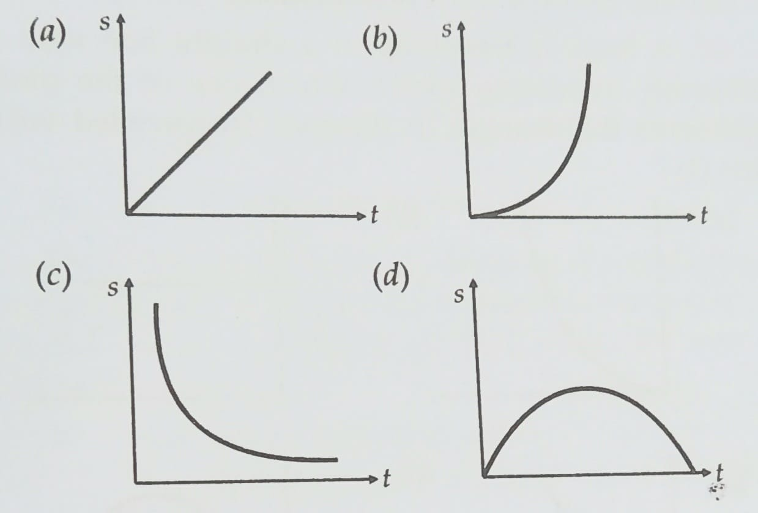
(iv) The motion of particle is described by the equation u =at . The distance travelled by particle in first 4 sec is
(a)4a (b) 12a (c) 6a (d) 8a

