UDAYA PUBLIC SCHOOL, AYODHYA
SUMMATIVE ASSESSMENT –I 2022-23
CLASS- II | SUBJECT- E.V.S. | M.M.- 60
Name:______________ Roll No.: _____

- Fill in the blanks with the right word. 5
(206, blood, living, skeleton, muscles, 300)
- A new born baby has about _____________ bones.
- The framework of bones in the body is called _____________.
- There are _____________ bones in our body.
- The heart supplies _____________ to all parts of our body.
- _____________ are between the bones and skin of our body.
- Match the following. 4
Column A Column B
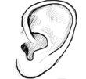
- sight

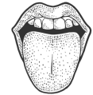
- feel

- 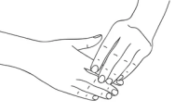 taste

- 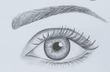 hear
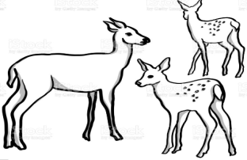
- Write the name of the animals shown in the following pictures. Give the name of their young ones. 4
- ___________________________________

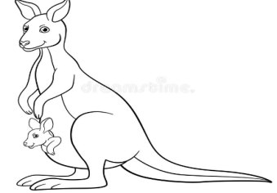

- ___________________________________

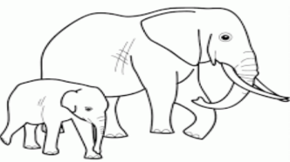

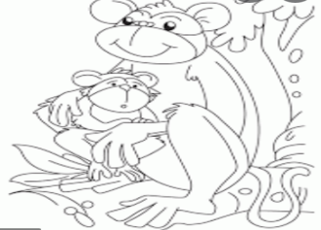

- __________________________________

- ___________________________________

- Unjumble the letters and find the movement associated with different types of animals. 4
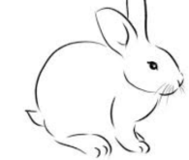
- POH
_______________

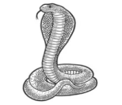
- LAWRC
_______________
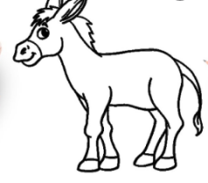

- LOGPAL
_______________

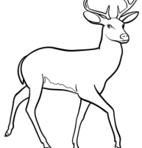
- PEAL
_______________

- Match the organs with the work they do. 4
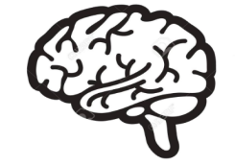
- Breathing

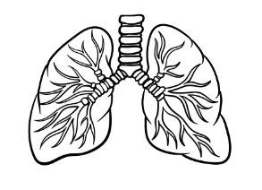
- Digesting

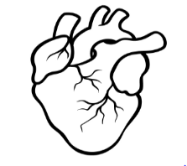
- Thinking

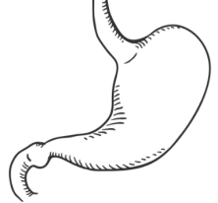
- Pumping

- Write ‘Yes’ or ‘No’ for the following: 4
- Tongue helps us to hear. __________
- We use nose to watch television. __________
- Eyes help us to know about different colours, shapes and sizes. __________
- All human beings have one nose.

- Read the following statements and write True or False. Rewrite the false statements correctly. 4
- Brain is present inside our chest. ( )
- The skin, stomach and bone work together to help our body move. ( )
- There are 306 bones in our body. ( )
- The skin is covered with skeleton which acts as a blanket. ( )
- Name the following: 3
- The animal with a long trunk. ____________________
- The animal with a long neck. ____________________
- The animal that has a shell on its back. ____________________
- Classify the items as Sweet, Salty, Bitter and Sour. 8
Coconut Cookies | Tamarind | Milk Chocolate
Fried rice | Bitter gourd | Potato chips

Sweet | Salty | Bitter | Sour

- Read the different sounds listed below and write whether they are natural or man-made. 5
Objects making sound | Natural or Man-made
- Crying of a baby
- Blowing of the wind
- Ringing of our school bell
- Meow of a cat
- Playing of a guitar

- Answer the following questions: 8
- Name the object with which you strike the coins into the pockets of the carom board.
____________________________________________________________________
____________________________________________________________________
- How many players can play chess together?
____________________________________________________________________
____________________________________________________________________
- What are outdoor games?
____________________________________________________________________
____________________________________________________________________
- Name two games that have goalkeepers in them.
____________________________________________________________________
____________________________________________________________________

- Draw a picture of one food that you love to eat for lunch. 7

